
THE LIGHTHOUSE

Newsletter for November 2014

Your word is a lamp to my feet and a light for my path. Psalm 119:105

Message from Our Pastor

One of the joys of growing up in the flat farmlands of the eastern upper peninsula was being able to see home from a long way off. I remember as a child riding home from town after dark and, as we approached our neighbors' place, being able to see the light in the kitchen window of our home, though it was nearly a mile away. I recall still how seeing that light made me feel: like I was returning to a place of refuge, a place I could be myself, where I was known and accepted, where I would find nourishment and rest and welcome and reunion - a place where I belonged.

Of course, it wasn't seeing the window that made me feel all that; it was knowing who was in that house. That farmhouse window of my childhood home is gone, the house torn down. But the light in the window remains. I can still see it. I am thankful for the family that made me feel like that, and a family that still does.

Today, as I look toward the month of November I am reminded of thankfulness, maybe because we look forward to celebrating Thanksgiving Day. While I do look forward to that family celebration around these holidays – all the food, football, visiting relatives, decorations, festive music, and so on – I am also most mindful of my thankfulness for the Church, maybe because November 30 is the first Sunday of Advent (the New Year’s Day for the Church). Maybe I find myself being thankful for the Church because I have been home recovering from surgery on my neck, and the prayers and cards and calls and visits from my church brothers and sisters have been inspiring, comforting, and encouraging (thank you!).

Yet another reason for my thankfulness is that I have been thinking about church as my home. It is home to a wonderful gathering of people whom I miss when I have to be away. I miss the worship with its ancient words, and symbols, and motions, and prayers, and songs. I miss seeing Jesus there (this is my body, given for you; this is my blood, shed for you...). I miss the abundant smiles, and handshakes, and hugs, and how-are-yas, and conversations. I miss my friends, my brothers and sisters in Christ, the ones walking with canes, or bouncing by in sneakers, or crying their little cries for attention.... I miss seeing Jesus there (for where two or three are gathered...).

And you know, don't you, that no matter who you are, the Church is your home, too. Not only is there a place for you, but, according to Jesus, you belong there (Jesus...cried out, “Let anyone who is thirsty come to me...”).

The light of Christ shines out through the worship and ministries of Zion and Trinity throughout southern Mackinac County. And even if you're a long way off from those church buildings, I bet you can still see their lights. I hope you can, because it’s your home. If you're looking for a place to meet Jesus, a place of refuge, a place to be yourself, a place to find nourishment and rest and welcome and reunion - a place where you belong – then come on home.

Pr. Lamb
Matt Lamb, Interim Pastor
Newsletter

The Newsletter was not adopted.

Noisy Offering

The noisy offering for November 2nd will go for the Food Pantry

All Saint’s Day

November 1st is All Saint’s Day. This is a day in the church when we remember all the baptized who’ve gone before us. In the past year, we have buried the following saints:
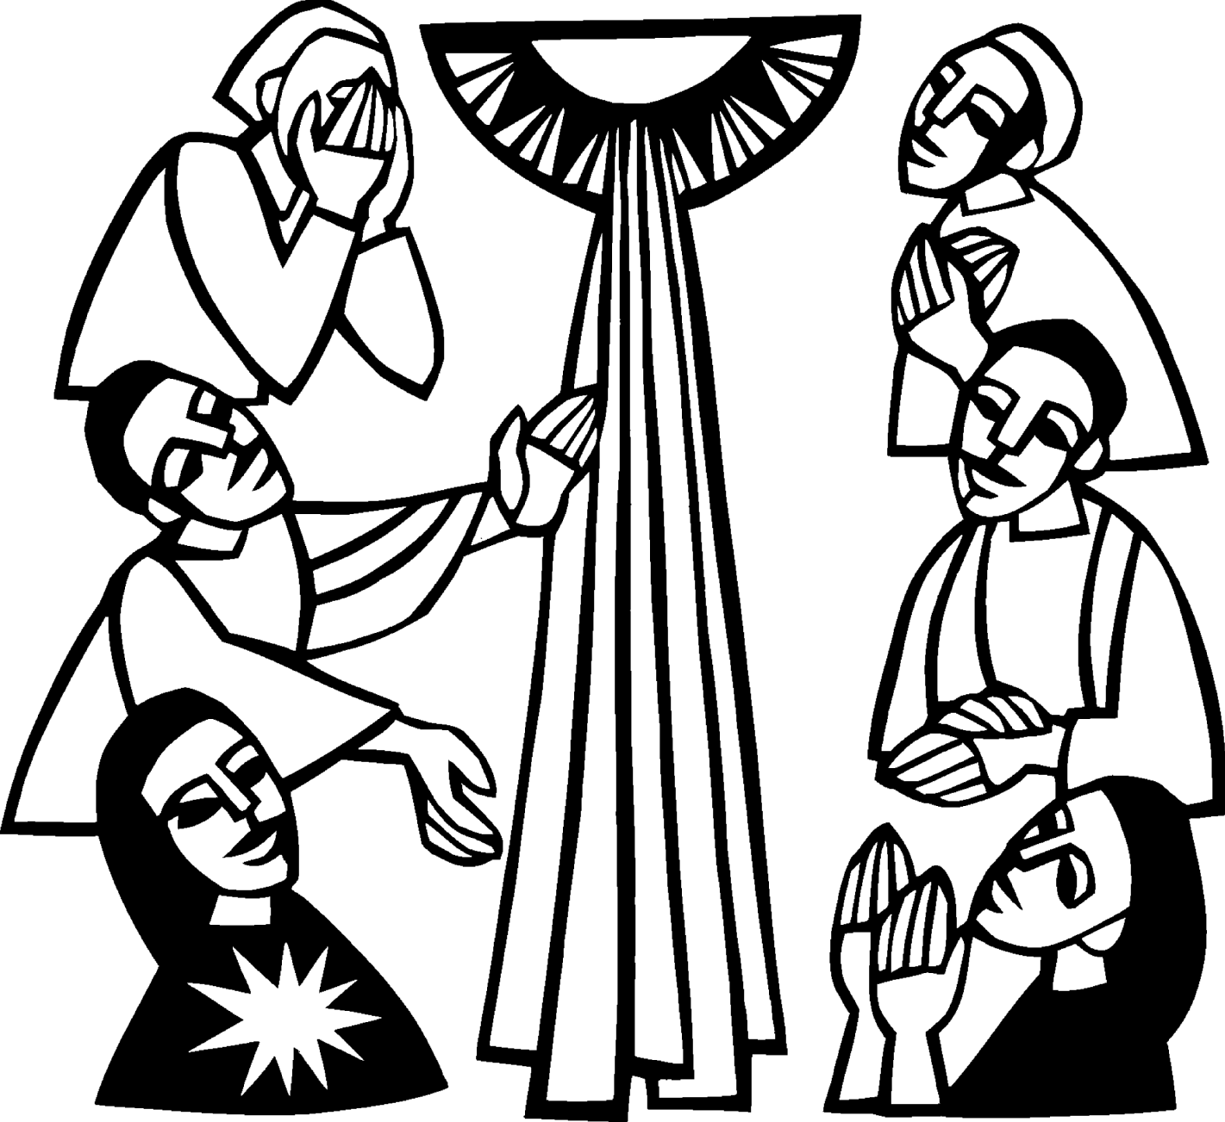

Jim Campbell
Eleanor Christianson
Ruth Cope
Anne Dyer

Confirmation

There will be a Confirmation Meeting for parents and youth on November 5th at 7 pm. This includes all youth 6th – 8th grade. If you can’t make it, please call Lana (643-6576) to get information. This will start the regular confirmation meetings for the youth, on the first two Wednesdays of the month.

NOIZ

Sunday, November 16th at 7 – 9 pm, all High School Youth are invited to come to church as we gather together for snacks, games, and conversation.

Community Service

Community Service will be offered by the NOIZ group and the Confirmation groups. If you need leaves raked, or other odd jobs, please contact Nicole Garen (643-8387) or Lana Lennington (643-6576).

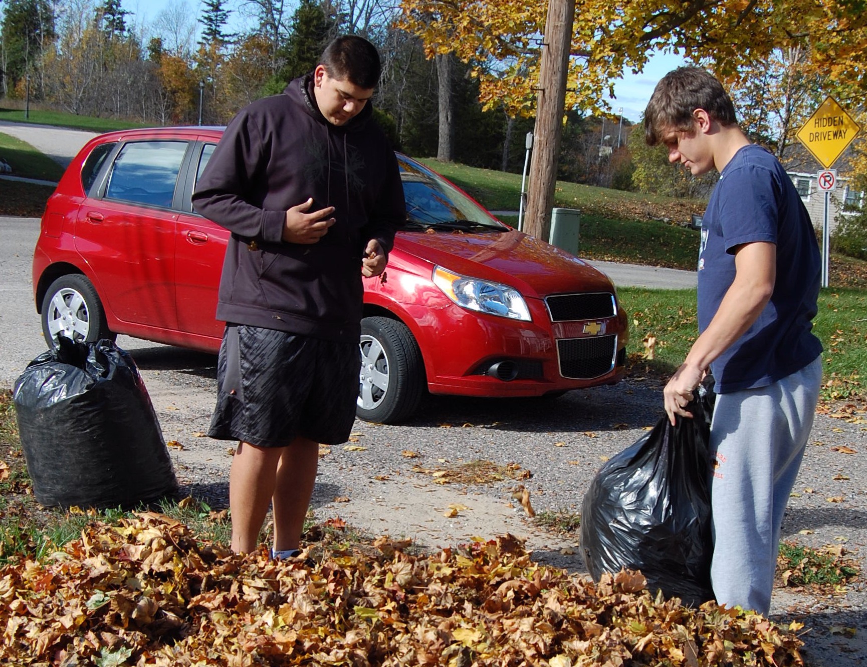

Cole Garen and David LaVake raking leaves.

Youth Gathering in Detroit

The ELCA Youth Gathering for high school-age youth (8th thru 12th) takes place every three years and is about faith formation, worship, study, fellowship, service and play.
It is an opportunity for youth to engage with peers from across the United States and the world who share a common commitment and faith in Christ. The next Gathering will be held July 15-19, 2015, in Detroit, Mich.
The Gathering is a five-day event that begins on a Wednesday evening and ends with a service of communion the following Sunday morning. The opening night sets the stage for the days ahead in which young people may have an encounter with Jesus that energizes their faith and helps them discover their call to serve in the world — locally and globally.
On the days between Wednesday and Sunday, young people rotate through a variety of service learning experiences in the surrounding community. They explore and strengthen their faith by studying God’s word, serving their neighbor, sharing bread and wine in worship, participating in lively faith discussions and broadening their experience of God’s world and diverse communities through travel.
We will be raising money for the Youth Gathering by collecting pop cans and recycling toner and inkjet & laser print cartridges. Any contributions will be appreciated. Anyone wanting to go, please contact Nicole Garen (643-8387) or Lana Lennington (643-6576).

Contact Information

Interim Pastor: Dr. Orv Kabat may be reached at (cell) 906-630-0361 or (home) 906-478-7531

Church telephone: 906-643-7870 - Answering machine
The secretary will be in the office on Tuesday and Thursday mornings.

To email the church is: ziontrinity950@yahoo.com
The new website is at http://zionstignace.com/home.html
- Find us on facebook at www.facebook.com/zionstignace

Prayer List

( If you would like someone added to the prayer list, please fill out a yellow card or call the church)


Bonnie Bergeron, Jim Dyer, Carl & Mary Belonga, LaTaunya Paquin, Christine Movalson Shaw, Lois Movalson, Phil Richel, Joy Olsen Marolf, Jim Scott, Bob Pearson, Susan Stelzer, Rob Podlesak, Judy Childs, Jackie Kallstrom, Judy Schlehuber Bridges, Terry Jacobson, Sandy White, Beverly Kammers, Terry Howard, Doris McFarland, Ray Burton, Janet Kanitz, Frank Feher, Phil Schaeffer, Charlie Lamoreaux, Hallie Marshall, George Ford, Kay Allot, Wayne Chapple, Kathy Essary, Philip Huff, Ruth Visnaw, Brenda St. Onge, Krista Empie, Pastor Matt Lamb, James Dandona, the family of Ruth Cope, the family of Eleanor Christianson, the family of Karen Cronan Meehan, the family of Ed Knight and the family
of Richard McKenzie.

We Need You!
Pastor Jeremy may be gone but the building is still standing. We have a variety of great people taking over to share the good news.

All we need is you! Join us to share the songs, the sermons and the fellowship.

Lorraine Graham
Church Secretary

Birthdays in November

November 3 Tim Idalski
4 Ernie Vallier
4 Linda Wilkins
7 Rita LaVake
11 Kathy Marshall
11 Samantha Wyers
12 Shirley Winberg
15 Nancy Hardy
15 Alicia LaLonde
17 Faith Gaubault
17 Wyatt Huhn
17 Kyra Spencer
18 Lori Bowlby
19 Connie Olsen
19 Justin Stenson
22 Lisa Gamble
23 Shirley Campbell
25 Dawn Akers
26 Misti Gamble
28 Gloria Marshall
29 Jessie Rogers
30 Virginia Hopper

Baptimal Anniversaries

November 2 Joshua LaJoice

November 12 Misti Gamble
November 13 Tim Idalski
November 14 Adrian Coleman
November 14 Madison Coleman
November 17 Kristen Olsen
November 21 Duane Gamble
November 25 LaRoy Hill
November 27 Mike Wilkins
November 27 Mandy Fenlon

Anniversaries in November

November10 Judy & Don Massey

Trinity Worship Families

Nov 2 Movalson Family
Nov 9 Kennedy Family
Nov 16 Rose Family
Nov 23 Gustafson Family
Nov 30 Chalmers Family

Zion Funeral Committee August-November

Team Leader: Linda Wilkins (643-7710)
Co-leader: Rita LaVake (906) 298-0005

Servants for Zion

Ushers & Greeters
Nov 2 Nicole Garen Family
Nov 9 Sam LaVake Family
Nov 16 Confirmation Youth
Nov 23 Amy Dodds Family
Nov 30 Max Coburn & Robert Marshall

Lectors
Nov 2 Betsy Turf
Nov 9 Rita LaVake
Nov 16 Dawn Akers
Nov 23 Linda Wilkins
Nov 30 Paul Shepard

Communion Assistants
Nov 2 Fred Feleppa
Nov 9 Faith Gaubault
Nov 16 Lana Lennington
Nov 23 Paul Shepard

Acolytes
Nov 2 Matthew Valetta
Nov 9 Drew Stokero
Nov 16 Sarah Doran
Nov 23 Madison Olsen
Nov 30 Kennedy Music

Pulpit Supply
Nov 2 Kerry Shimkovitz
Nov 9 Mike Herman
Nov 16 Dan Litzner (Native American Sunday)
Nov 23 Mike Herman
Nov 23 Community Thanksgiving Service - Dan Litzner
Nov 30 Kerry Shimkovitz
Altar: Karen Schlehuber
Money Counters: Judy Ryerse & Susan Fenlon
November 23^{rd:} Long Term Care Service. Help out if you can.

Calendar Notes

Daylight Savings Time changes on November 2nd. Turn your clocks back.
Smoke detector batteries should be replaced at least once a year. People often change them when the clocks change.

Election Day is November 4th. Your vote counts! ☑

Veteran’s Day is November 11th. 


November 27th - Happy Thanksgiving!

Leftover dishes

There are various dishes left over from donations to the soup
luncheons, funerals, etc. They have been taken upstairs. We appreciate your help. Check to see if you’ve forgotten one.
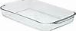

Council Meetings

Trinity Council Meeting – 6 pm, November 5th
Zion Council Meeting – 6:30 pm, November 19th

Zion’s Council Members

President: Faith Gaubault 298-1800
Vice-President Paul Shepard 984-2069
Secretary: Lorraine Graham 643-8419
Co-Treasurers: Dawn Akers 643-7552
Lana Lennington 643-6576
Nicole Garen 643-8387
Tim Idalski 643-6574
Fred Feleppa 643-6793

Trinity’s Council Members

President: Jerri Rose 292-5570
Vice-President Tracy Movalson 292-5581
Secretary: Sharon Chalmers 292-5440
Treasurer: Pega Kennedy 292-5633
Co-Treasurer: Jim Rose 292-5570
Financial Secretary: Joe Chalmers 292-5433
WELCA: Pega Kennedy 292-5633
John Kennedy 292-5633
Jim Dyer 292-5433
Lois Movalson 292-5581
Treasurer's Report for Zion
January 1, 2014 to October 18, 2014
Income:
 | Building | $ 5,237.00
 | Church Use Income | $ 150.00
 | Thrivent Financial Income | $ 339.00
 | General | $ 45,643.08
 | Trinity Share | $ 10,710.00
 | TOTAL |  | $ 62,079.08
Expenses:
 | Administration | $ 4,399.65
 | Benevolence | $ 3,083.64
 | Church Maintenance | $ 12,347.53
 | Education | $ 790.24
 | Parsonage Maintenance | $ 2,099.63
 | Pastoral | $ 33,775.36
 | Worship | $ 3,103.00
 | --To Building Fund | $ 3,103.00
 | --To LCF Loan | $ 500.00
 |  |  | $ 63,202.05
 |  |  | -1,122.97
***********************************************************
General fund balance: |  |  | $ 570.45
Building fund balance: |  |  | $ 301.14
WELCA Kitchen Savings acct balance: |  |  | $ 686.43
General fund owes building fund: |  |  | $ 1,010.00
General fund owes Mission Endowment fund: |  |  | $ 9,495.00

Zion Lutheran Council Meeting
October 15, 2014
Present: Pastor Lamb, Dawn Akers, Fred Feleppa, Nicole Garen, Lorraine Graham, Lana Lennington and Paul Shepard

Paul Shepard opened the meeting at 6:40 p.m. Pastor Lamb led us in devotions and a prayer with a special mention for the family of Ed Knight.

Pastor’s Report:

As Pastor Lamb is having surgery tomorrow, our new interim pastor will be Orv Kabat. Next in line would be Bree Johnson of Cedarville.

Over the last month he presided over two council meetings, one funeral and one wedding.

The Treasurer’s Report was presented.

There was no Secretary Report.

New Business:

NOIZ will start this Sunday at 7 pm. Nicole will preside over the meeting and if she needs help Samantha LaVake will help out. It was decided to put it in the schools announcements.

Lana has volunteered to head confirmation as she has had experience doing so when Pastor Tari left. Pastor Lamb said he thought that Pastor Jeremy had left the information we would need to get going. Lana will look for the folder. We decided to have confirmation on the first two Wednesdays of the month, again this year. The first meeting is to include the confirmands and their parents.

We decided to have the NOIZ and Confirmands do service for the community such as raking leaves, etc. If anyone has a project, let a council member know.

We still need money for the Building Fund for the roof. It was suggested we have a soup luncheon in November. We decided to check with the WELCA ladies to see if they wanted to do one. It was decided to send a thank you note to the Marlene Olsen family for their generous donation to the Building Fund.

Pastor Lamb said he hadn’t asked Mike Herman to do the service for Long Term Care on November 23rd. It was decided to ask Dan Litzner, if Mike Herman wasn’t available. Dan will be doing the Community Thanksgiving Service at Zion that evening.

We discussed the upcoming Youth Gathering in Detroit. We need to find out who wants to go and find out how much we will money we will need for each student. It was mentioned that Pastor Tari was bringing students to the Gathering from Alaska and that she might stop by in St. Ignace on their way there. We will be collecting pop cans and recycling toner and laser and inkjet cartridges to raise money.

It was mentioned that the light over the kitchen sink always blinks and goes out. It was suggest we check to see if it’s just needs to be tightened.

It was mentioned that the rack over the kitchen’s center island was never put up. It was suggested we check with Jerry.

It was mentioned that most of the ushers were not aware that they should bring the money downstairs after the service as it was not on the list of usher duties. We voted that the money should be taken downstairs by the Altar people or the Money Counters depending on who is there.

The meeting adjourned with the Lord’s Prayer at 7:45 p.m.

Respectfully submitted,
Lorraine Graham

Adoption Programs
Lutheran Social Services of Wisconsin & Upper Michigan, Inc. is in urgent need of families for our domestic infant & international adoption programs. Countries include: Bulgaria, Kyrgyzstan, Philippines, China, Marshall Islands, Ethiopia, India and others.

Four informational meetings will be held in November, with times and dates listed below. Meetings will last approximately one to one and a half hours.

Nov, 3rd– Monday @ 6pm , Immanuel Lutheran Church
600 S. Lincoln Road , Escanaba, MI
Nov. 4th – Tuesday @ 7pm, LSS Adoption Office
1029 North Third Street, Marquette, MI
Nov. 5th – Wednesday @ 6pm , Gloria Dei Lutheran Church
1000 Quincy Street, Hancock, MI
Nov. 6th – Thursday @ 12pm, LSS Adoption Office
1029 North Third Street, Marquette, MI

Pre-registration is required by calling 906-226-2160, ext 14
If you cannot attend, please contact Kerry Wiese to set up an individual appointment to start the process. Motivated by the Compassion of Christ, we promote security for children.

